## Subalpine Conifer (SCN)

**General Information**

**Cover Type Overview**

**Subalpine Conifer (SCN)**

* Area under simulation: 5,028 acres / 2,035 hectares
* Project area only: 1,573 acres / 636 hectares
* 1,570 acres / 635 hectares
* Crosswalk to EVeg: Regional Dominance Type 1
  + Alpine Mixed Scrub
  + Mountain Hemlock
  + Subalpine Conifers
  + Whitebark Pine
* Crosswalk to EVeg: Regional Dominance Type 2
  + Any
* Crosswalk to Presettlement Fire Regime Type
  + Subalpine
* Crosswalk to LandFire Biophysical Settings
  + 0610330 Mediterranean California Subalpine Woodland
  + 0610440 Northern California Mesic Subalpine Woodland
  + 0610710 Sierra Nevada Alpine Dwarf-Shrubland

**Subalpine Conifer with Aspen (SCN-ASP)**

* Area under simulation: 73 acres / 30 hectares
* Project area only: 18 acres / 7 hectares
* This type is created by overlaying the NRIS TERRA Inventory of Aspen on top of the EVeg layer. Where it intersects with SCN it is assigned to SCN-ASP.

**Vegetation Description**

**Subalpine Conifer (SCN)** The subalpine landscape is comprised of a mosaic of subalpine forests/woodlands, meadows, rock outcrops, and scrub vegetation types. Subalpine forests are open stands of conifers occurring on generally sandy soils or rocky slopes at elevations above the upper montane forest stands of *Abies magnifica*. Stand densities are low. Many, but not all, species form shrubby krummholz forms of growth near their upper elevational limits (Fites-Kaufman 2007).

*Tsuga mertensiana* is often the most common tree species and mixes with *P. contorta* ssp. *murrayana*, *A. magnifica*, and *Pinus monticola*. In some areas, *P. contorta* ssp. *murrayana* dominates post-disturbances stands. *T. mertensiana* seedlings are relatively shade tolerant compared to other subalpine conifers and do well under closed canopy conditions. *P. albicaulis* presence increases in the southern portion of the project area (Fites-Kaufman 2007, LandFire 2007a).

Treeline growth of multistemmed trees and shrubby krummholz growth of conifers varies with latitude in the Sierra Nevada. Treeline in the northern Sierra Nevada is dominated by *Pinus albicaulis*, which frequently occurs with a krummholz form of growth near its upper limit. Several other species may also form krummholz growth forms, including Sierra juniper, *Tsuga mertensiana, P. contorta* ssp. *murrayana*, and rarely *Pinus jeffreyi* (Fites-Kaufman 2007).

Although typically of minor importance, a shrub understory may include *Arctostaphylos, Ribes, Phyllodoce, Vaccinium,* and *Kalmia* can occur on moist sites. Herbs present may include *Lupinus, Hieracium, Arabis, Aster,* and *Erigeron. Carex* and various grasses are also common in the sparse ground cover (Verner and Purcell 1988, LandFire 2007a).

**Subalpine Conifer with Aspen (SCN-ASP)** When *Populus tremuloides* co-occurs with LPN on the west side of the Sierran crest, it is typically found in smaller patches, often less than 2 ha (5 acres) in size. Mature stands in which *P. tremuloides* are still dominant are usually relatively open. Average canopy closures range from 60 to 100 percent in young and intermediate-aged stands and from 25 to 60 percent in mature stands. The open nature of the stands results in substantial light penetration to the ground (Verner 1998).

**Distribution**

**Subalpine Conifer** The elevational distribution of subalpine forest communities varies with latitude. In the northern Sierra Nevada, such stands begin around 2,450 m and extend up to treeline at 2,750 to 3,100 m (9,000 to 11,000 ft). Both upper and lower limits of subalpine species distributions are driven by a variety of factors, including soil resources, water availability, and climatic limiting factors (Fites-Kaufman 2007).

SCN forests are characterized by a relatively short growing season with cool temperatures. With the exception of occasional summer thunderstorms, most precipitaiton falls as snow. Wet years with abundant snowfall can limit growth as these may produce late-lying snowfields that reduce the length of the growing season. Winds can be severe, particularly around exposed ridges. Such wind conditions may produce snow-free winter areas that lower soil temperatures and increase plant water stress (Fites-Kaufman 2007).

Because of the solid granite parent material, areas with deeper soil accumulation can become waterlogged for much of the year. For these reasons, the length of the growing season is a function of early season limitation due to low temperatures and snowfields, and late season limitations due to drough. Studies of the dynamics of alterations of treeline elevation over the past several millennia have reinforced the significance of complex interactions of both temperature and seasonal water availability in determining such changes (Fites-Kaufman 2007).

**Subalpine Conifer with Aspen** Sites supporting *P. tremuloides* are associated with added soil moisture, i.e., azonal wet sites. These sites are found throughout the SCN zone, often close to streams, lakes, and meadows. Other sites include rock reservoirs, springs and seeps. Terrain can be simple to complex. At lower elevations, topographic conditions for this type tends toward positions resulting in relatively colder, wetter conditions within the prevailing climate, e.g., ravines, north slopes, wet depressions, etc. (LandFire 2007b).

**Disturbances**

**Wildfire**

**Subalpine Conifer** Most of the SCN areas of the Sierra Nevada were subjected to repeated glaciation during the Pleistocene, and thus have thin and poorly developed soils with little organic matter. The small amounts of litter accumulation and open stand structure of subalpine forests mean that fire is rare (Fites-Kaufman 2007). It is, however, the major disturbance event of this type (LandFire 2007a). Meyer’s 2013 review suggests that historic and current fire regimes in subalpine forests are both climate-limited and dominated by either surface fires or a combination of surface fires with occasional crown fires.

Data on fire return intervals (FRIs) are available from a few review papers. Van de Water and Safford’s 2011 review paper aggregates hundreds of articles, conference proceedings, and LandFire data on fire return intervals, with an emphasis on Californian sources. We also include here data from the pertinent individual LandFire BpS models (2007a, 2007b).

Estimates of wildfire return interval for subalpine forests range from 57 to over 500 years (Meyer 2013). Van de Water and Safford (2011) found a mean fire return interval of 133 years, a median of 132 years, a mean min of 100 years and a mean max of 420 years for subalpine forest. The LandFire model for northern California Nevada subalpine woodland predicts a mean FRI of 321 years. Replacement FRI has a mean of 500 years, while the mean mixed severity FRI is 900 years, and low severity fire is not modeled (2007a). We recalculated these numbers using condition-specific information and using only high and low mortality fire categories, which resulted in a mean FRI of 500 years for high mortality fire, 923 years for low mortality fire, and 324 years for any fire.

**Subalpine Conifer with Aspen** Sites supporting *P. tremuloides* are maintained by stand-replacing disturbances that allow regeneration from below-ground suckers. Upland clones are impaired or suppressed by conifer ingrowth and overtopping and intensive grazing that inhibits growth. In a reference condition scenario, a few stands will advance toward conifer dominance, but in the current landscape scenario where fire has been reduced from reference conditions there are many more conifer-dominated mixed aspen stands (LandFire 2007b, Verner 1988).

Van de Water and Safford (2011) found a mean fire return interval of 19 years, median of 20 years, mean min interval of 10 years and mean max of 90 years. The LandFire model for northern Sierra Nevada aspen that is seral to conifers predicts a mean FRI of 37 years. Replacement FRI has a mean of 150 years with a range of 50-300 years, while mixed severity FRI is 250 years, and low severity fire FRI is 60 years (2007b). We reconceptualized the successional stages and converted fire activity to high and low mortality categories, which resulted in a mean FRI of 92 years for high mortality fire, 91 years for low mortality fire, and 46 years for any fire.

Table 1. Fire return intervals (years) and percentage of high versus low mortality fires in relation to soil type modifier and the presence of *P. tremuloides*. Numbers for SCN were derived from BpS model 0610440, Van de Water and Safford (2011) and Meyer (2013). Numbers for SCN-ASP were derived from BpS model 0610610 (LandFire 2007b) and Safford (pers. comm. 2013).

|  |  |  |  |  |  |
| --- | --- | --- | --- | --- | --- |
| **Variant** | **Fire Mortality** | **Mean** | **Min** | **Max** | **% of Fires** |
| SCN | High | 500 | – | – | 65 |
| Low | 923 | – | – | 35 |
| All Fires | 324 | 57 | 420 | 100 |
| SCN -ASP | High | 92 | – | – | 50 |
| Low | 91 | – | – | 50 |
| All Fires | 46 | 20 | 200 | 100 |

**Other Disturbance**

Other disturbances are not currently modeled, but may, depending on the condition affected and mortality levels, reset patches to early development, maintain existing condition classes, or shift/accelerate succession to a more open condition.

**Vegetation Condition Classes**

We recognize five separate condition classes for SCN and SCN-ASP. The condition classes described below are based on the classes described in the pertinent LandFire Biophysical Setting model descriptions, which in turn were based on a “5-box” state and transition models describing major successional stages related to fire regime condition classification. According to the Fire Regime Condition Class guidebook, up to five successional classes may be utilized to describe age, size, canopy cover, and vegetation composition, ranging from early seral (post-disturbance) to late seral (such as old growth) (Barrett et al. 2010).

The SCN variant is assigned to five separate condition classes: Early Development (ED), Mid Development Open (MDO), Mid Development Closed (MDC), Late Development Open (LDO, and Late Development Closed (LDC). The SMC-ASP variant is also assigned to five condition classes: Early Development – Aspen (ED-A), Mid Development – Aspen (MD-A), Mid Development – Aspen with Conifer (MD-AC), Late Development Closed (LDC), and Late Development – Conifer with Aspen (LD-CA).

**Subalpine Conifer Variant**

**Early Development (ED)**

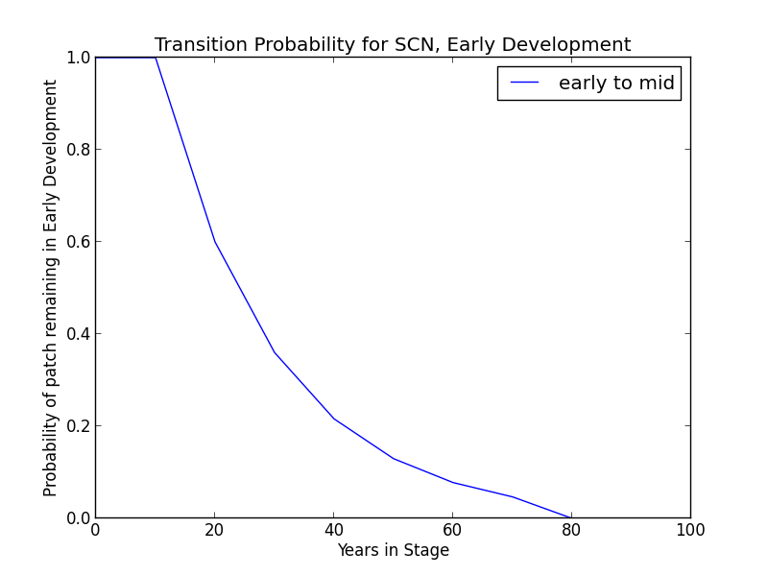**Description** The first few years following stand-replacing wildfire are characterized by bare ground, herbs, shrubs, and varying densities of tree seedlings (presumably dependent on seed sources). Dominant species include coniferous tree seedlings, resprouting grasses and shrubs, and invading herbs. Shrubs include *Ribes* spp. Herbs and grasses include *Aster*, *Pedicularis*, *Hieracium*, *Arabis*, *Erigeron*, *Carex*, *Luzula*, and *Poa* (LandFire 2007a).

**Succession Transition** In the absence of disturbance, this condition will begin transitioning to mid development after 20 years at a rate of 0.4 per time step. Transition to either MDC or MDO can occur, although transition to MDC occurs 90% of the time. At 80 years, all stands will have succeeded.

**Wildfire Transition** High mortality wildfire (100% of fires) recycles the patch through the Early Development condition. Low mortality wildfire is not modeled for this condition.

**Mid Development - Open (MDO)**

**Description** This condition represents delayed tree regeneration and long-term domination by shrubs and herbs. Shrubs include *Ribes* spp. Herbs and grasses include *Aster*, *Pedicularis*, *Hieracium*, *Arabis*, *Erigeron*, *Carex*, *Luzula*, and *Poa*. Trees are represented by seedlings and saplings of *T. mertensiana, P. contorta* ssp. *murrayana*, and other species (LandFire 2007a).

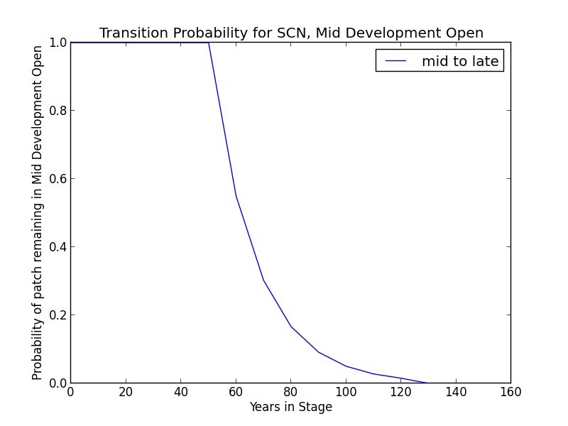**Succession Transition** This condition will maintain under low mortality disturbance, but after 60 years without fire it begins transitioning to LDO at a rate of 0.45 per time step. Succession to LDO may occur once the age since transition to an MD condition for that patch is at least 60 years, even if the patch has shifted between the MDC and MDO condition classes. After 130 years, all stands will have succeeded. Succession to MDC is not modeled.

**Wildfire Transition** High mortality wildfire (60% of fires) recycles the patch through the Early Development condition. Low mortality wildfire (40%) maintains the patch in MDO.

**Mid Development - Closed (MDC)**

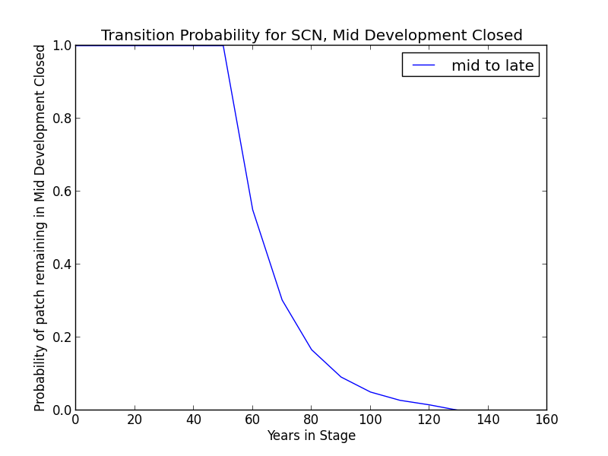**Description** This condition class represents rapid regeneration by *P. contorta* ssp. *murrayana*, with additional conifers coming in including *T. mertensiana, A. magnifica,* and *P. monticola.* Shrubs include *Ribes* spp. Herbs and grasses include *Aster*, *Pedicularis*, *Hieracium*, *Arabis*, *Erigeron*, *Carex*, *Luzula*, and *Poa*. (LandFire 2007a).

**Succession Transition** After 60 years without a wildfire-triggered transition, this condition will begin transitioning to LDC at a rate of 0.45 per time step. Patches moving between MDC and MDO begin transitioning after 60 years since transition to mid development. After 130 years, all stands will have succeeded.

**Wildfire Transition** High mortality wildfire (66.7% of fires) recycles the patch through the Early Development condition. Low mortality wildfire (33.3%) triggers a transition to MDO.

**Late Development - Open (LDO)**

**Description** This condition class represents late-successional stands with large individuals (greater than 20in DBH) of *T. mertensiana* and other species, with open stand structure maintained by mixed severity fire and insect-caused tree mortality. Shrubs include *Ribes* spp. Herbs and grasses include *Aster*, *Pedicularis*, *Hieracium*, *Arabis*, *Erigeron*, *Carex*, *Luzula*, and *Poa*. (LandFire 2007a).

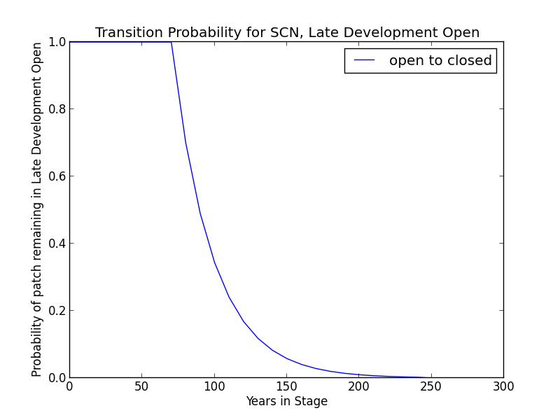**Succession Transition** In absence of fire natural succession to LDC occurs after 80 years at a rate of 0.3 per timestep.

**Wildfire Transition** High mortality wildfire (60% of fires) recycles the patch through the Early Development condition. Low mortality wildfire (40%) maintains the patch in LDO.

**Late Development - Closed (LDC)**

**Description** This condition class represents late-successional stands with large individuals (greater than 20in DBH) of *T. mertensiana* and other species, advanced regeneration of *T. mertensiana* and other shade tolerant species, and typical understory species. Shrubs include *Ribes* spp. Herbs and grasses include *Aster*, *Pedicularis*, *Hieracium*, *Arabis*, *Erigeron*, *Carex*, *Luzula*, and *Poa*. (LandFire 2007a).

**Succession Transition** This condition class will maintain in the absence of disturbance.

**Wildfire Transition** High mortality wildfire (66.7% of fires) recycles the patch through the Early Development condition. Low mortality wildfire (33.3%) maintains the patch in LDC.

**Aspen Variant**

**Early Development – Aspen (ED–A)**

**Description** Grasses, forbs, low shrubs, and sparse to moderate cover of tree seedlings/saplings (primarily *P. tremuloides*) with an open canopy. This condition is characterized by the recruitment of a new cohort of early successional, shade-intolerant tree species into an open area created by a stand-replacing disturbance.

Following disturbance, succession proceeds rapidly from an herbaceous layer to shrubs and trees, which invade together (Verner 1988). *P. tremuloides* suckers over 6ft tall develop within about 10 years (LandFire 2007b).

**Succession Transition** Unless it burns, a patch in the ED–A condition persists for 10 years, at which point it transitions to MD-A.

**Wildfire Transition** High mortality wildfire (100% of fires) recycles the patch through the ED–A condition. Low mortality wildfire is not modeled for this condition.

**Mid Development – Aspen (MD–A)**

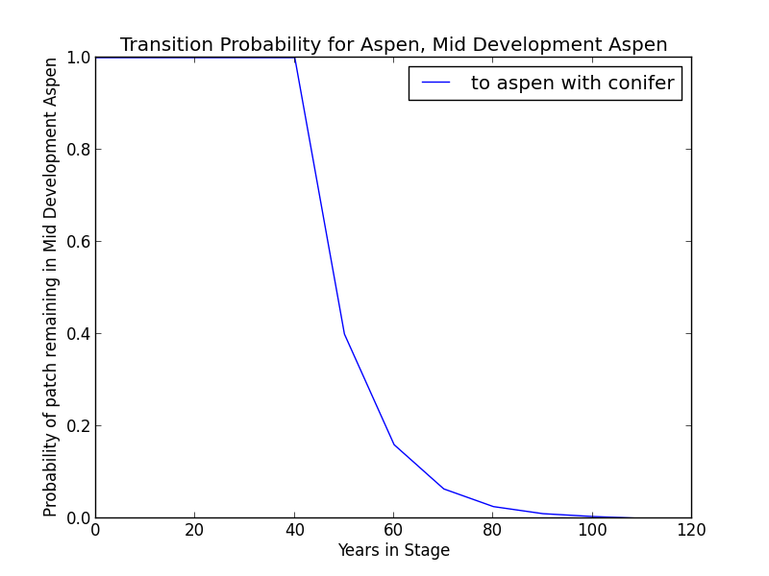**Description** *P. tremuloides* trees 5-16” DBH. Canopy cover is highly variable, and can range from 40-100%. These patches range in age from 10 to 110 years. Some understory conifers, predominantly *T. mertensiana,* are encroaching, but *P. tremuloides* is still the dominant component of the stand (LandFire 2007b).

**Succession Transition** MD-A persists for at least 50 years in the absence of fire, after which stands begin transitioning to MD-AC at a rate of 0.3 per timestep. After 200 years since entering MD-A, any remaining patches transition to MD-AC.

**Wildfire Transition** High mortality wildfire (100% of fires in this condition) recycles the patch through the ED–A condition. Low mortality wildfire is not modeled for this condition.

**Mid Development – Aspen with Conifer (MD–AC)**

**Description** These stands have been protected from fire for at least 100 years. *P. tremuloides* trees are predominantly 16” DBH and greater. Conifers (predominantly *T. mertensiana*) are present and overtopping the aspen. Conifers are pole to medium-sized, and conifer cover is at least 40% (LandFire 2007b).

**Succession Transition** MD-AC persists for 100 years in the absence of fire, after which stands transition to LDC.

**Wildfire Transition** High mortality wildfire (28.4% of fires) returns the patch to ED-A. Low mortality wildfire (71.6%) maintains the patch in MD- AC.

**Late Development – Closed (LDC)**

**Description** Some *P. tremuloides* continue to be present in the understory, but large *T. mertensiana* are now the dominant tree species, having overtopped the *P. tremuloides.* Smaller conifers are present in the midstory as well (LandFire 2007a).

**Succession Transition** This condition class will maintain in the absence of disturbance.

##### **Wildfire Transition** High mortality wildfire (9% of fires in this condition) will return the patch to ED–A. Low mortality wildfire (91%) usually has little effect, although 15% of the time it opens the stand up to LD-CA.

**Late Development – Conifer with Aspen (LD–CA)**

**Description** If stands are sufficiently protected from fire such that conifer species overtop *P. tremuloides* and become large, they may be able to withstand some fire that more sensitive *P. tremuloides* cannot. When this occurs, it creates a patch characterized by late development conifers, such as *T. mertensiana,* *P. contorta* ssp. *murrayana*, *A. magnifica*, or *Pinus monticola*, and early seral *P. tremuloides*.

**Succession Transition** LD-CA persists for 70 years in the absence of fire, after which stands transition to LDC.

**Wildfire Transition** High mortality wildfire (20% of fires in this condition) returns the patch to ED-A. Low mortality wildfire (80%) maintains the stand in LD-CA.

**Condition Classification**

Table 2. Classification of cover condition for SCN. Diameter at Breast Height (DBH) and Cover From Above (CFA) values taken from EVeg polygons. DBH categories are: null, 0-0.9”, 1-4.9”, 5-9.9”, 10-19.9”, 20-29.9”, 30”+. CFA categories are null, 0-10%, 10-20%, … , 90-100%. Each row in the table below should be read with a boolean AND across each column.

|  |  |  |  |  |  |
| --- | --- | --- | --- | --- | --- |
| Cover Condition | Overstory Tree  Diameter 1 (DBH) | Overstory Tree  Diameter 2 (DBH) | Total Tree  CFA (%) | Conifer  CFA (%) | Hardwood  CFA (%) |
| Early All | null | any | any | any | any |
| Early All | 0-4.9” | any | any | any | any |
| Mid Open | 5-19.9” | any | null | null | null |
| Mid Open | 5-19.9” | any | <50 | any | any |
| Mid Open | 5-19.9” | any | null | <50 | null |
| Mid Closed | 5-19.9” | any | >50 | any | any |
| Mid Closed | 5-19.9” | any | null | >50 | any |
| Late Closed | 20”+ | any | >50 | any | any |
| Late Closed | 20”+ | any | null | >50 | any |
| Late Open | 20”+ | any | null | null | null |
| Late Open | 20”+ | any | <50 | any | any |
| Late Open | 20”+ | any | null | <50 | null |

Methodology for assigning condition classes to SCN-ASP is still under development.

**Draft Model**

(See PDF) Disturbance-Succession model for SCN and SCN-ASP.

**References**

Fites-Kaufman, Jo Ann, Phil Rundel, Nathan Stephenson, and Dave A. Wixelman. “Montane and Subalpine Vegetation of the Sierra Nevada and Cascade Ranges.” In *Terrestrial Vegetation of California, 3rd Edition*, edited by Michael Barbour, Todd Keeler-Wolf, and Allan A. Schoenherr, 456-501. Berkeley and Los Angeles: University of California Press, 2007.

LandFire. “Biophysical Setting Models.” Biophysical Setting 0610440: Northern California Mesic Subalpine Woodland. 2007a. LANDFIRE Project, U.S. Department of Agriculture, Forest Service; U.S. Department of the Interior. <http://www.landfire.gov/national_veg_models_op2.php>. Accessed 9 November 2012.

LandFire. “Biophysical Setting Models.” Biophysical Setting 0610610: Inter-Mountain Basins Aspen-Mixed Conifer Forest and Woodland. 2007b. LANDFIRE Project, U.S. Department of Agriculture, Forest Service; U.S. Department of the Interior. <http://www.landfire.gov/national_veg_models_op2.php>. Accessed 7 January 2013.

Meyer, Marc D. “Natural Range of Variation of Red Fir Forests in the Bioregional Assessment Area” (unpublished paper, Ecology Group, Pacific Southwest Research Station, 2013).

Safford, Hugh S. Personal communication, 5 May 2013.

Van de Water, Kip M. and Safford, Hugh D. “A Summary of Fire Frequency Estimates for California Vegetation Before Euro-American Settlement.” *Fire Ecology* 7.3 (2011): 26-57. doi: 10.4996/fireecology.0703026.

Verner, Jared. “Aspen (ASP).” *A Guide to Wildlife Habitats of California*. 1988. Mayer, Kenneth E. and Laudenslayer, William F., eds. California Department of Fish and Game. <http://www.dfg.ca.gov/biogeodata/cwhr/pdfs/ASP.pdf>. Accessed 4 December 2012.